# HTML & CSS – Homework

For this homework, we are going to put into practice what we’ve learned so far about HTML and CSS. If you haven't already, please ensure that you have completed the HTML and CSS Labs before attempting this homework.

Redesigning your favorite website

In class we recreated an article from TechCrunch. For this assignment you will recreate and restyle a page from one of your favorite websites. The conceptual goal of this homework is to help you understand that the same content can be restyled in different ways. When presentation is abstracted from content, we have separated these two concerns, making it easier for us to make changes to one or the other.

Instructions

1. Choose a page from one of your favorite websites. Please choose a page that has at least some written content.
2. On paper, draw out how you perceive the content to be structured and nested, like we did in class on Wednesday during the HTML lecture. Ignore advertisements and other content you deem unimportant. The goal isn’t to re-create every single detail.
3. On a separate piece of paper, draw out a new layout for the content. At a minimum, make element sizing and position changes
4. Code your re-designed page in HTML. Copy over any content (text or images) from the original page. You can use screenshots in place of videos. Save this HTML file as hw2.html
5. Add a navigation bar if there is not already one. It can have a fixed position or not.
6. Create a new visual style for the page so that it feels different than the original. Focus on typography, color, and margins/padding. Use a separate CSS file for styling; the HTML file you created should not contain any styling. Save the CSS file as hw2.css
7. Bonus: Repeat steps 3-6 to create a second set of HTML and CSS files with a different layout and style. Save these files as hw2b.html and hw2b.css

Note: It’s not important to mimic or alter every single detail of the original web page. It’s also not important that your re-designed page is beautiful – this is not a visual design course. Do your best to pick up on the major page elements and push yourself to create styling different enough that the page has a completely different feel.

## Submitting Your Homework

You are going to submit your homework via Git. Using the shell, navigate to your IOLab directory. If you are in the correct directory, you should be able to run “git status” and see something like below:

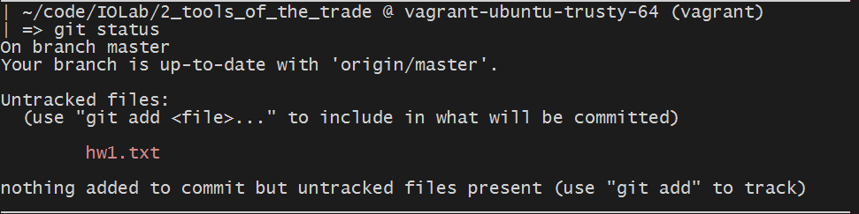

Before you add the homework and submit it, first create a new branch by running:

git checkout –b hw-2-branch

After you create a branch, stage the hw2 file, commit, and push the changes to your repository. You can do that by running the following commands:

git add .

git commit –m “submitting hw2”

git push origin hw-2-branch

As a final step, navigate to your repository on Github. You should see something similar to this page, click on “Compare & Pull Request”.

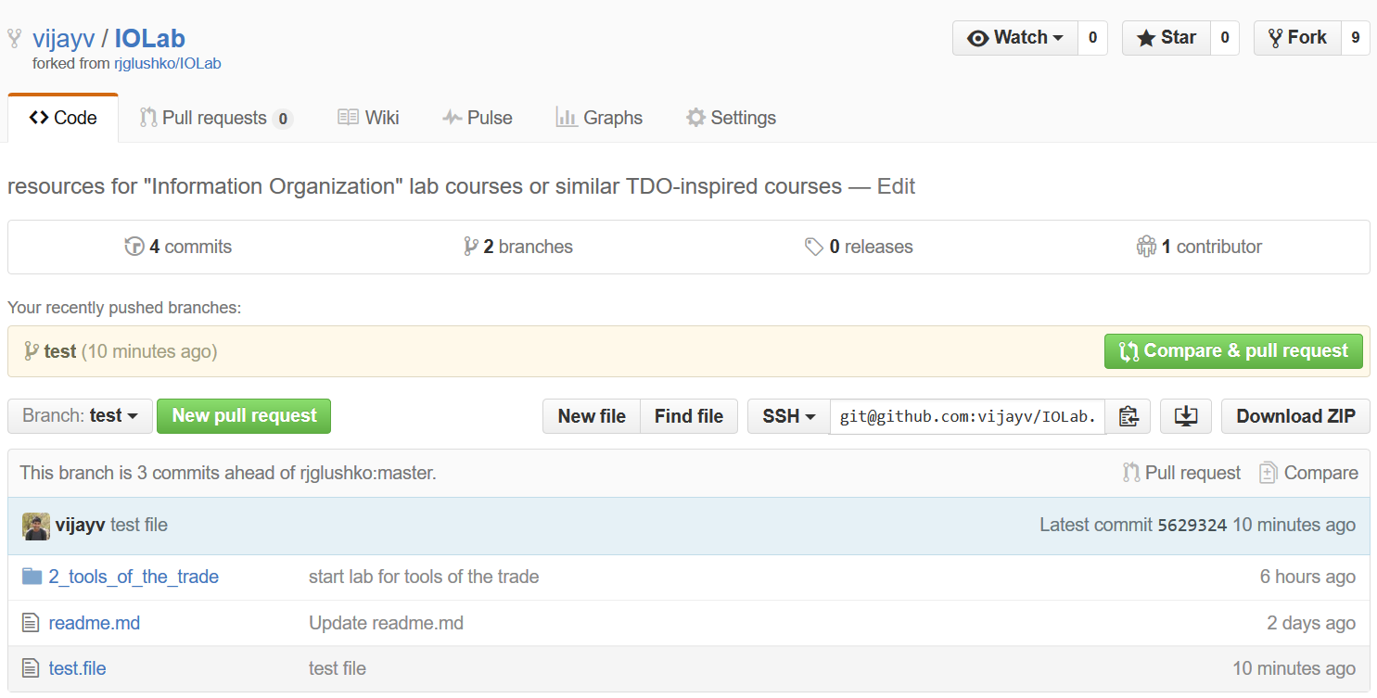

In the following page, you will see something similar to below:

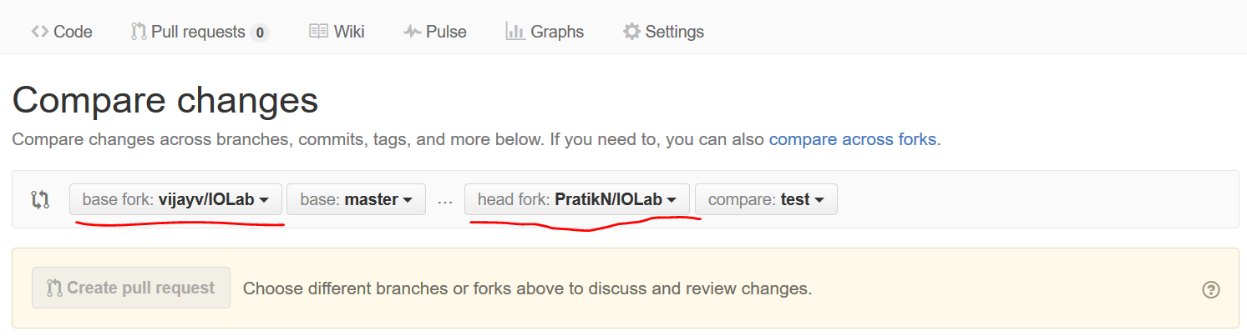

Ensure that you select the base fork as “vijayv/IOLab” and select the head fork as your own, and the branch to hw-2-branch. Finally, you can click “Create Pull Request” to submit your homework.

** The reason for turning in your code in this manner is because it allows to give you pointed feedback on your code inline. This is a common practice in the industry and is formalized through a process called a code review. If you are interested, you can read more about it here: [http://blog.codeship.com/github-code-review/.](http://blog.codeship.com/github-code-review/)